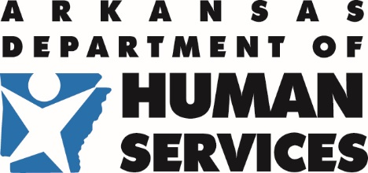 | Division of Child Care and Early  Childhood Education | 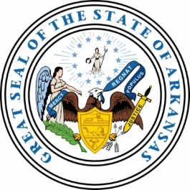
P.O. Box 1437, Slot S140 · Little Rock, AR 72203-1437
501-682-8590 · Fax: 501-683-6060 · TDD: 501-682-1550

MEMORANDUM

TO: All Child Nutrition Programs
FROM: Health and Nutrition Office
DATE: June 15, 2020
SUBJECT: April 2020 Claim 60-day Deadline

Department of Human Services-Health and Nutrition Unit
Claim for meal reimbursements: CACFP, NSLP, and SFSP

The deadline to submit the April 2020 claim for meal reimbursements will be June 29, 2020. Please have the April 2020 claim submitted by this deadline.

Note: This alert is being distributed to all providers, regardless if the April 2020 claim has been submitted. If you have submitted the April 2020 claim, please disregard this email.
If you are having any technical problems submitting this claim, please see the contact information listed below to receive assistance:

Robert Majors
Email: Robert.majors@dhs.arkansas.gov
Phone: 501-396-6121

Ursula Perry
Email: Ursula.perry@dhs.arkansas.gov
Phone: 501-396-6151

Thank you.

Please keep this memo on file for quick and easy reference. A copy is also available on the resource library-Mass Alerts. If you have any questions regarding this memo, please contact your Program Specialist at: 501-682-8869.

