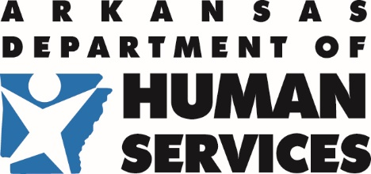 | Division of Child Care and Early  Childhood Education | 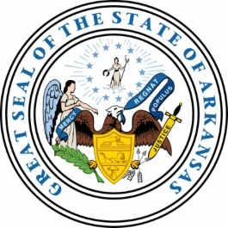
P.O. Box 1437, Slot S140 · Little Rock, AR 72203-1437
501-682-8590 · Fax: 501-683-6060 · TDD: 501-682-1550

MEMORANDUM

TO: 2020 Summer Food Service Program Participants
FROM: DCCECE / HNU
DATE: May 11, 2020
SUBJECT: 2020 Summer Food Service Program Application Deadline Extended to May 15th

This is a notice regarding 2020 Summer Food Service Program (SFSP) Application Deadline. We are currently extending applications for 2020 SFSP through May 15, 2020. You have 5 days left to submit your SFSP Application.

Programs choosing to participate in the 2020 SFSP have an extension to submit their application. The extension deadline is May 15, 2020 by 5:00 pm. Any application submitted after the extension deadline will not be approved, thus your program will not receive any reimbursements throughout the entire length of your summer program.

Please check the status of your application immediately. If your application is “Approved/Amended” you have completed the application process and you are ready to start your summer feeding program for 2020, Congratulations.

If your application is in “Pending Approval” you have not been approved by your Application Specialist. Contact your Application Specialist immediately to find out what you need to complete your application. If your application is in “Pending Submission” your application has not reached the point of being reviewed by your Application Specialist.

If you have yet to open your 2020 SFSP application, time is running out. For those programs that choose to submit their application at the last minute will run the risk of not having your application processed in a timely manner. If your application is not submitted by the deadline, it will be denied.

Please keep this memo on file for quick and easy reference. A copy is also available on the resource library under HNP Mass Alerts. If you have any questions regarding this memo, please contact your Health and Nutrition Unit at: 501-682-8869.

Summer Food Service Program (SFSP)
APPLICATION SUBMISSION DEADLINE
MAY 15, 2020

