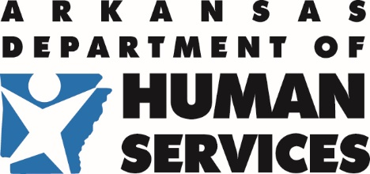 | Division of Child Care and Early  Childhood Education | 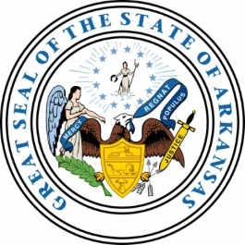
P.O. Box 1437, Slot S140 · Little Rock, AR 72203-1437
501-682-8590 · Fax: 501-683-6060 · TDD: 501-682-1550

MEMORANDUM

TO: CACFP, SFSP, and NSLP
FROM: Health and Nutrition Program Unit
DATE: January 15, 2019
SUBJECT: 60-day Claim Deadline for November 2018

Department of Human Services-Health and Nutrition Unit
Claim for meal reimbursements: CACFP, NSPL, and SFSP

The deadline to submit the November 2018 claim for meal reimbursements will be January 29, 2019. Please have the November claim submitted by this deadline.

Note: This alert is being distributed to all providers, regardless if the November claim has been submitted. If you have submitted the November claim, please disregard this email.
If you are having any technical problems submitting this claim, please see the contact information listed below to receive assistance:

Robert Majors
Email: Robert.majors@dhs.arkansas.gov
Phone: 501-396-6121

Ursula Perry
Email: Ursula.perry@dhs.arkansas.gov
Phone: 501-396-6151

Thank you

Please keep this memo on file for quick and easy reference. A copy is also available on the resource library under Financial Management & Budgets. If you have any questions regarding this memo, please contact your Program Specialist at: 501-682-8869.

